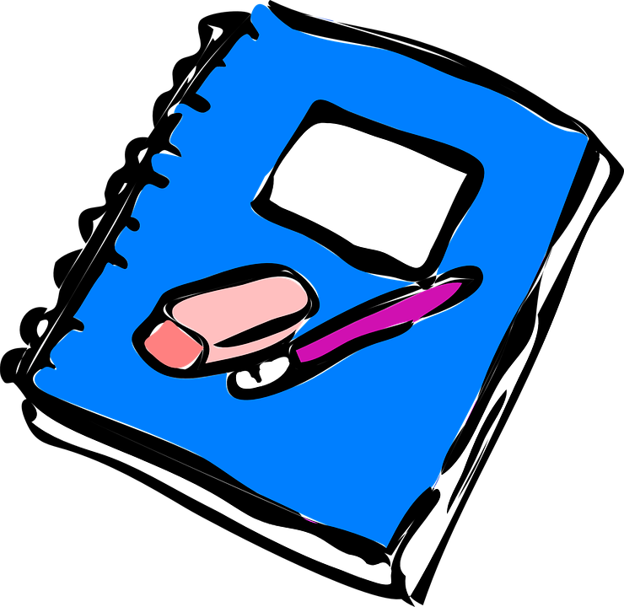
8th Grade School Supply List

1 composition notebook (for science fair)

Your own pens and pencils (hand operated sharpener suggested)

Ruler (inches and centimeters)

Subject notebooks of your choice

1 empty and cleaned, 2-liter soda bottle with cap (for 1st week of class)

Headphones in a Ziploc bag with your child’s name on it

