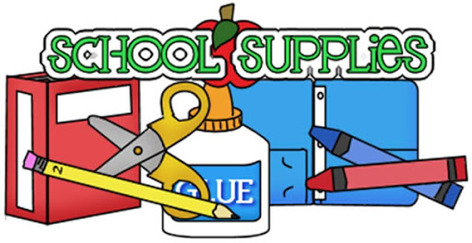Parents,
This is a list of some necessary items for your child that will help us begin our hybrid school year of learning. We would like each child to have their own items to use while in school for sanitary and safety reasons.

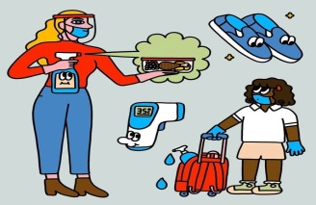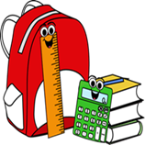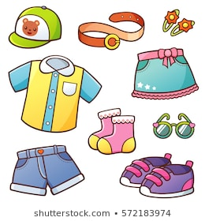
*A Backpack- (Inside your child’s Back Pack will be a COMMUNICATION FOLDER. We will use the folder to place important papers, forms and etc. in.

*2 Plastic (shoe box size) containers labeled with your child’s name for extra clothing, and art supplies.

*2 COMPLETE OUTFITS of clothing- (from head to toe)
*1 Sweater/Hoodie (to remain in school incase child gets cold)
*2 Extra Masks *1 Bottle of hand sanitizer
*1 Personal Water Bottle *2 Boxes of Facial Tissue
*2 Container –Disinfectant wipes
*2 boxes of Ziploc bags- (Quart or Gallon)
*1 Family Photo (this will remain in school all year)
*A Small Blanket for Rest time- (CRIB Sized) –Blankets come
in on MONDAY & go home on FRIDAY to be cleaned!
(Blankets must be in a 2 Galloon Zip-Lock Bag). 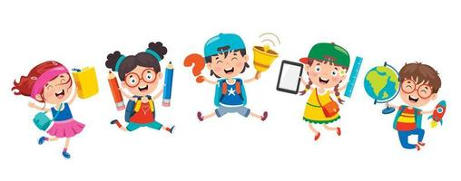
Child’s Personal Art Supplies
*4 Glue Sticks *1 Box of Markers
*2 Boxes of Crayons 8/16 Count
*3 or 4 small books (in Zip-Lock Bag)
**LABEL ALL YOUR CHILD’S BELONGINGS FOR SAFE KEEPING!

